**Contents:**

* Azure Services Used
* Architecture Diagram
* Architecture Details.
* Security
* Maintenance.

**Azure Services Used** –

* Azure Data Factory
* Azure Key Vault
* Azure Functions
* Azure Data Lake Gen2
* Azure DevOps

**Architecture Diagram –**

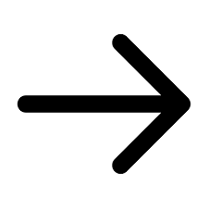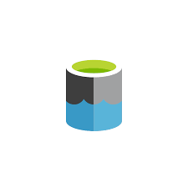





**Architecture Detail** –

1. **Azure Key Vault:**

* Azure Key Vault will be used for storing API token’s and Azure Data Lake Gen2 connection string securely and will be accessed by ADF.

1. **Azure Functions:**

* Will use Azure Functions Timer trigger to generate new token for API’s every 48 hrs. using existing token before existing token for API expire and replacing them in Azure Key Vault.

1. **Azure Data Factory:**

* Azure Data Factory will be used to create pipeline to fetch API data from API links provided and copying data into Azure Data Lake Gen2.
* Azure Data Factory will be triggered using schedule trigger every month.

1. **Azure Data Lake Gen2:**

* Azure Data Lake Gen2 will be used to csv/json payload from API.
* Will be creating or managing data/payload by creating separate folder for each source.

**Security** –

* Azure Data Factory will be using Managed Virtual Network and Private End Points to connect to other Azure Services like Azure Key Vault and Azure Data Lake Gen2 for secure connectivity and eliminates your data exposure to the internet.
* Azure Key Vault will be used for storing API tokens and Azure Data Lake Gen2 connection string as secrets
* Azure Functions will be using Managed Identities to access Azure Key Vault to access existing token and write new token to Azure Key Vault.
* Azure Data Factory will be using Managed Identities to access Azure Key Vault to access token for fetching payload data from API.

**Maintenance** –

* Will use Azure DevOps for doing CICD for above azure services and moving to different environments and productionizing them.